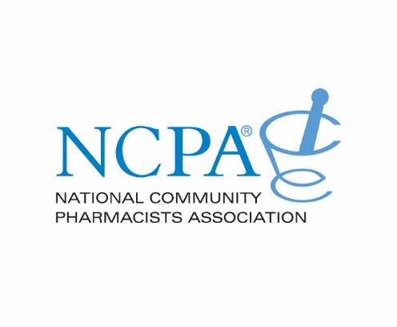
National Community Pharmacists Association
2017 NCPA Simplify My Meds Challenge
Due June 30

Name and Email of Officer Submitting Report

_________________________________________________________________________________________________________
School/College of Pharmacy

__________________________________________________________________________________________________________
How many events were held throughout academic school year:_______________________________________________

Description of the Simplify My Meds Events held:
Please use additional pages if needed

_____________________________________________________________________________________________________________
_____________________________________________________________________________________________________________
_____________________________________________________________________________________________________________
______________________________________________________________________________________________________________________
______________________________________________________________________________________________________________________
______________________________________________________________________________________________________________________
______________________________________________________________________________________________________________________
______________________________________________________________________________________________________________________
______________________________________________________________________________________________________________________
______________________________________________________________________________________________________________________
______________________________________________________________________________________________________________________
______________________________________________________________________________________________________________________
______________________________________________________________________________________________________________________
______________________________________________________________________________________________________________________
______________________________________________________________________________________________________________________
______________________________________________________________________________________________________________________

*********
_____________________________________________________________________________________________________________
NCPA Faculty Liaison/Chapter Advisor
_______________________________________________________________________________________________________
Email Phone

Nomination Deadline: June 30, 2017
Submit forms to studentaffairs@ncpanet.org
or mail to NCPA Attn: Student Affairs 100 Daingerfield Rd. Alexandria, VA 22314

